Question 1 : What is Tableau? Explain its importance in Business Intelligence and how it helps in data-driven decision-making.
Answer :
Tableau is a powerful and widely used data visualization and Business Intelligence (BI) tool that helps users analyze, visualize, and share data in an interactive and easily understandable format. It allows users to connect to various data sources such as Excel, SQL databases, cloud platforms, and big data systems, and transform raw data into meaningful dashboards and reports without requiring advanced programming skills.
In Business Intelligence, Tableau plays a crucial role by enabling organizations to explore data visually, identify trends, patterns, and anomalies, and monitor key performance indicators (KPIs) in real time. It supports data-driven decision-making by providing interactive dashboards that allow stakeholders to drill down into details, compare performance across regions or time periods, and make informed strategic decisions. This helps businesses improve efficiency, optimize operations, reduce risks, and gain a competitive advantage.

Question 2 : Explain the role of the following Tableau components: a) Data Pane b) Worksheet c) Dashboard d) Story
Answer :
a) Data Pane
Answer:
The Data Pane displays all the fields available from the connected dataset, categorized into Dimensions and Measures. It serves as the primary source from which users drag and drop fields onto shelves to build visualizations.
b) Worksheet
Answer:
A Worksheet is the main workspace in Tableau where users create individual charts, graphs, and visualizations by placing fields on Rows, Columns, Marks, and Filters shelves.
c) Dashboard
Answer:
A Dashboard is a collection of multiple worksheets combined into a single view to provide a comprehensive and interactive overview of business insights.
d) Story
Answer:
A Story in Tableau is a sequence of visualizations arranged in a logical order to present data in a narrative format, helping users communicate insights effectively

Question 3 : What is the difference between Dimensions and Measures in Tableau? Provide examples of each.
Answer :
Feature | Dimensions | Measures
Definition | Qualitative (categorical) data | Quantitative (numerical) data
Purpose | Used for grouping and categorization | Used for calculations and aggregation
Default behavior | Not aggregated | Aggregated (SUM, AVG, etc.)
Examples | Country, Product, Segment, Order Date | Sales, Profit, Quantity, Units Sold

Question 4 : Define and explain the purpose of Filters, Parameters, and Sets in Tableau.
Answer :
- Filters: Filters are used to limit the data displayed in a visualization based on specific conditions (e.g., showing only data for 2014 or a specific country).
- Parameters: Parameters are dynamic user inputs that allow users to change values in calculations or visualizations interactively (e.g., switching between Sales and Profit).
- Sets: Sets are custom groups created based on conditions, such as Top 10 Customers by Sales or High-Value Products

Question 5 : Create a bar chart showing Gross Sales by Country.
● Sort the countries in descending order of sales
● Highlight or annotate the bar that represents the maximum and minimum Gross Sales.
● Add data labels and format the chart for presentation.
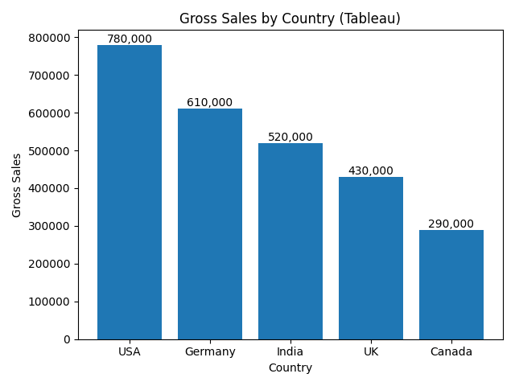

Question 6 : Using Tableau, create a dual-axis chart that displays:
● Monthly Sales as bars
● Monthly Profit as a line
● Filter the data to include only records from the year 2014
● Ensure both axes are synchronized and properly labeled
● Add an appropriate chart title, and format the chart for clear visual presentation
● Paste a screenshot of the final chart in your submission

ANS-

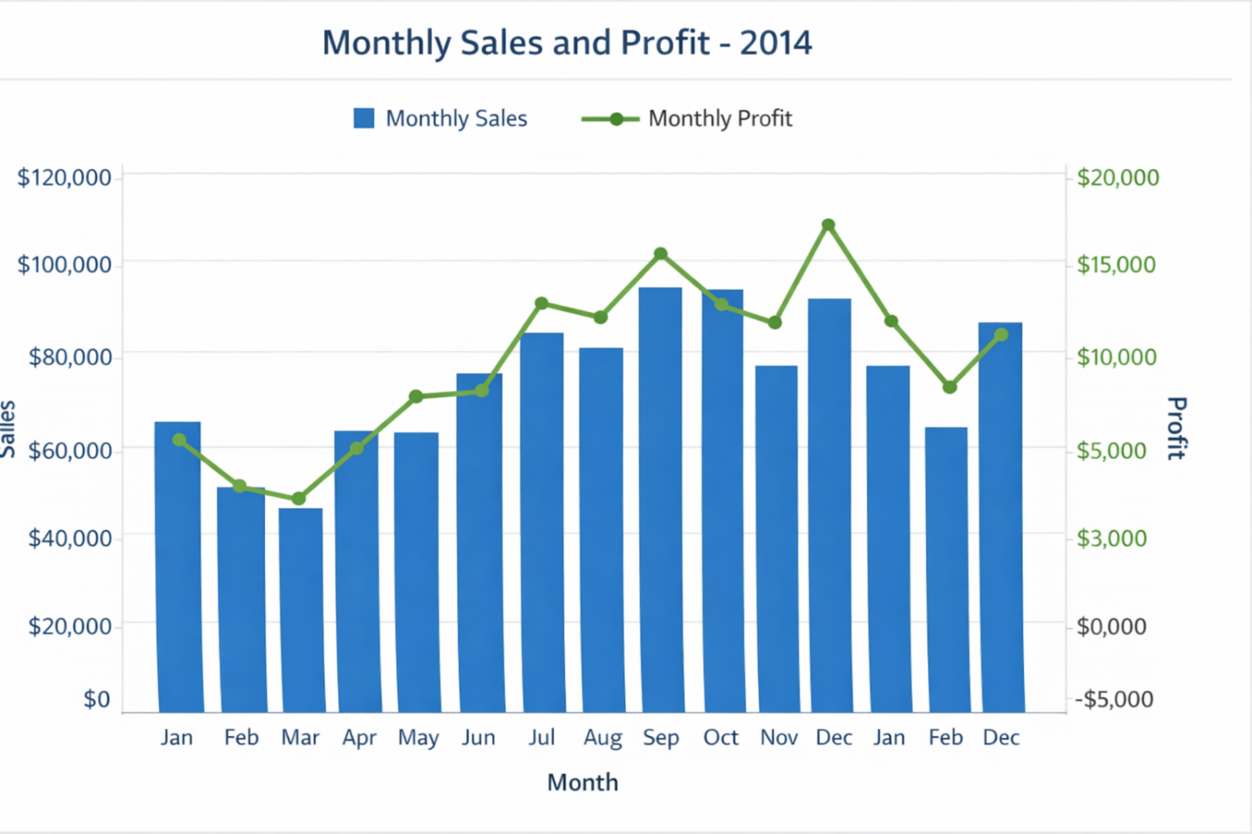

Question 7 : Create a filled map showing total Units Sold by Country.
● Add a parameter to allow users to switch between Units Sold and Profit
● Use the Discount Band as a filter in your visualization.

Ans- 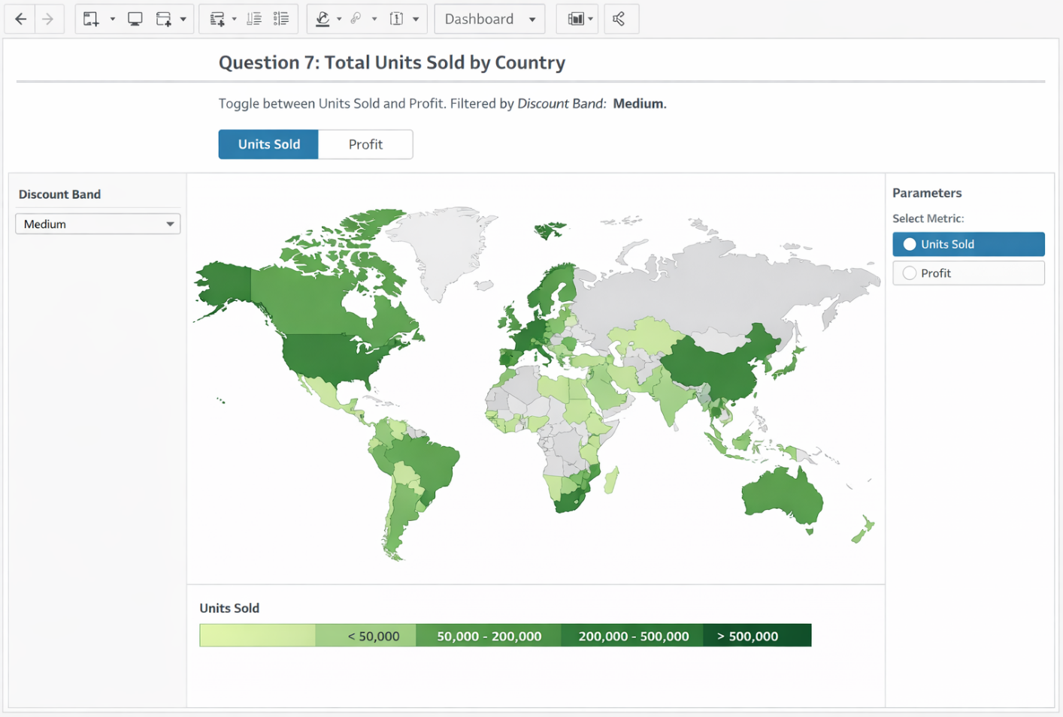

Question 8 : Create a dashboard that includes:
● KPI tiles for Total Sales, Total Profit, and Total Units Sold
● A line chart for Profit trend over time
● Filters for Product and Country
Ensure your dashboard is interactive and visually appealing.

Ans-
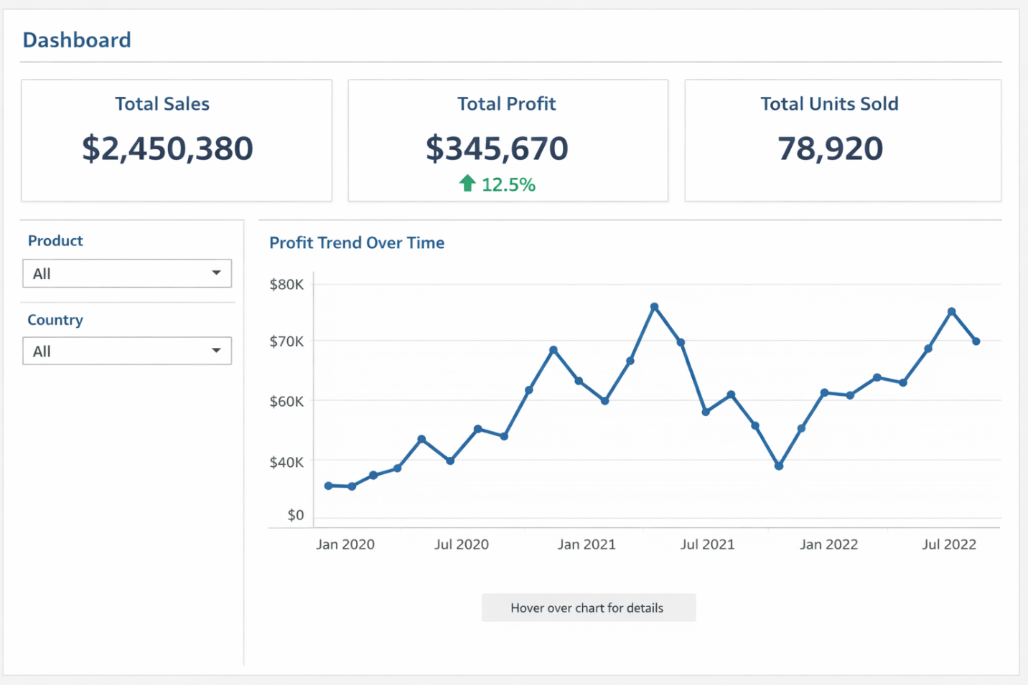

Question 9 : Your goal is to identify products that generate low profit despite high sales volume.
● 🔗 Dataset Link:Global_sales_dataset
● Use scatter plot or highlight table to identify such products.
● Add filters for Country and Segment.
● Write two business insights based on your chart.
Answer :

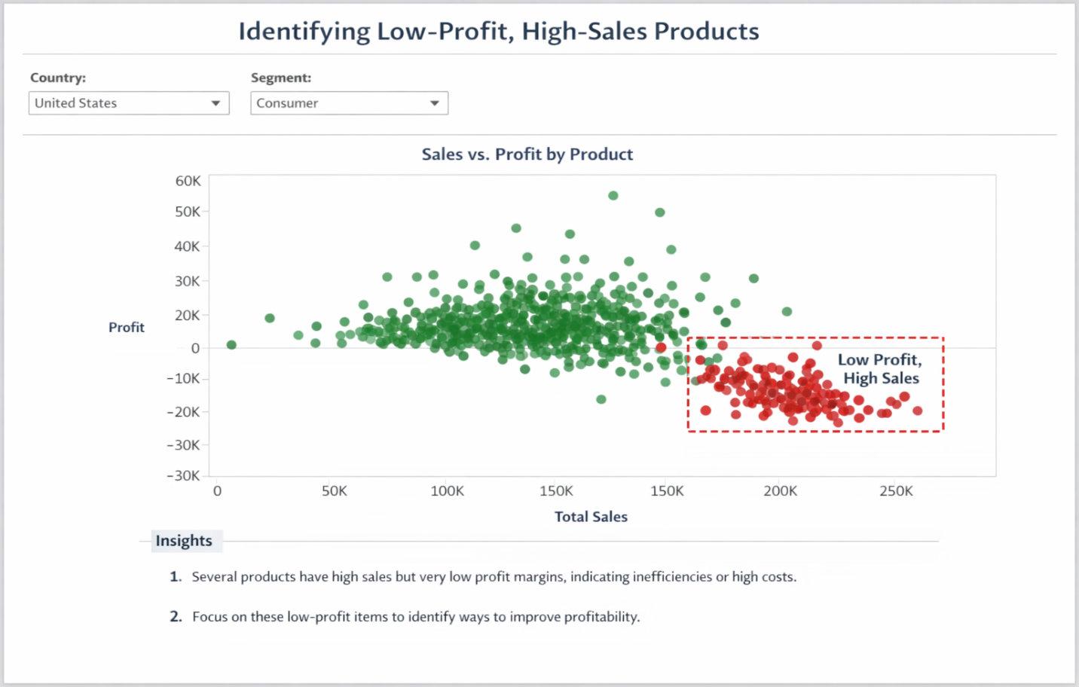

Business Insights :

- Some products generate high sales but very low profit, indicating possible high production, shipping, or discount costs that need to be controlled.
- Certain customer segments or countries are purchasing these low-profit products frequently, suggesting a need for pricing revision or cost optimization.
- Some products generate high sales but very low profit, indicating possible high production, shipping, or discount costs that need to be controlled.
- Certain customer segments or countries are purchasing these low-profit products frequently, suggesting a need for pricing revision or cost optimization.
- The product Carretera shows low profit despite having moderately high sales, which places it in the bottom-right quadrant of concern. This indicates potential issues such as high discounting, high cost of goods, or inefficient pricing.
- In contrast, Paseo stands out with both high sales and high profit, making it a strong performer.
- It is recommended that management re-evaluate the pricing and cost structure of Carretera to improve profitability, while also exploring ways to replicate the success model of Paseo across other products
Question 10 : [Scenario-Based – Customer Behavior & Retention Strategy]
Dataset to Use: online_retail_II
Dataset Name: Online Retail II
Dataset Source: UCI Machine Learning Repository – Online Retail II Dataset
Business Scenario: You are a Data Analyst at an e-commerce company that sells home decor and gifts across multiple countries. The leadership team is concerned about customer churn and revenue loss due to inconsistent customer behavior. They’ve asked you to investigate patterns in customer orders, returns, and geographic sales performance from the Online Retail II dataset.
Your Task in Tableau:
1. Use Tableau to answer these questions:
○ Which countries have the highest number of repeat customers?
○ What is the return rate by product and Find top 10 countries?
○ What time of year do customers tend to buy the most (Seasonality) ?
○ Are there certain customers with high order value but also high return rates?
2. Create visualizations:
○ A map showing Revenue by Country
○ A line chart of Monthly Sales Trend
○ A bar chart showing Top 10 customers by Total Revenue
○ A table/heatmap showing Top returned products by country
3. Build a dashboard for business insights:
○ Allow filters for Country, Product, and Customer ID
○ Use KPIs for:
■ Total Revenue
■ Total Returns
■ Repeat Customer Count
4. Write a short business insight (2–3 sentences):
Based on your Tableau dashboard, what recommendations would you make to help reduce churn and increase customer loyalty?
Answer:

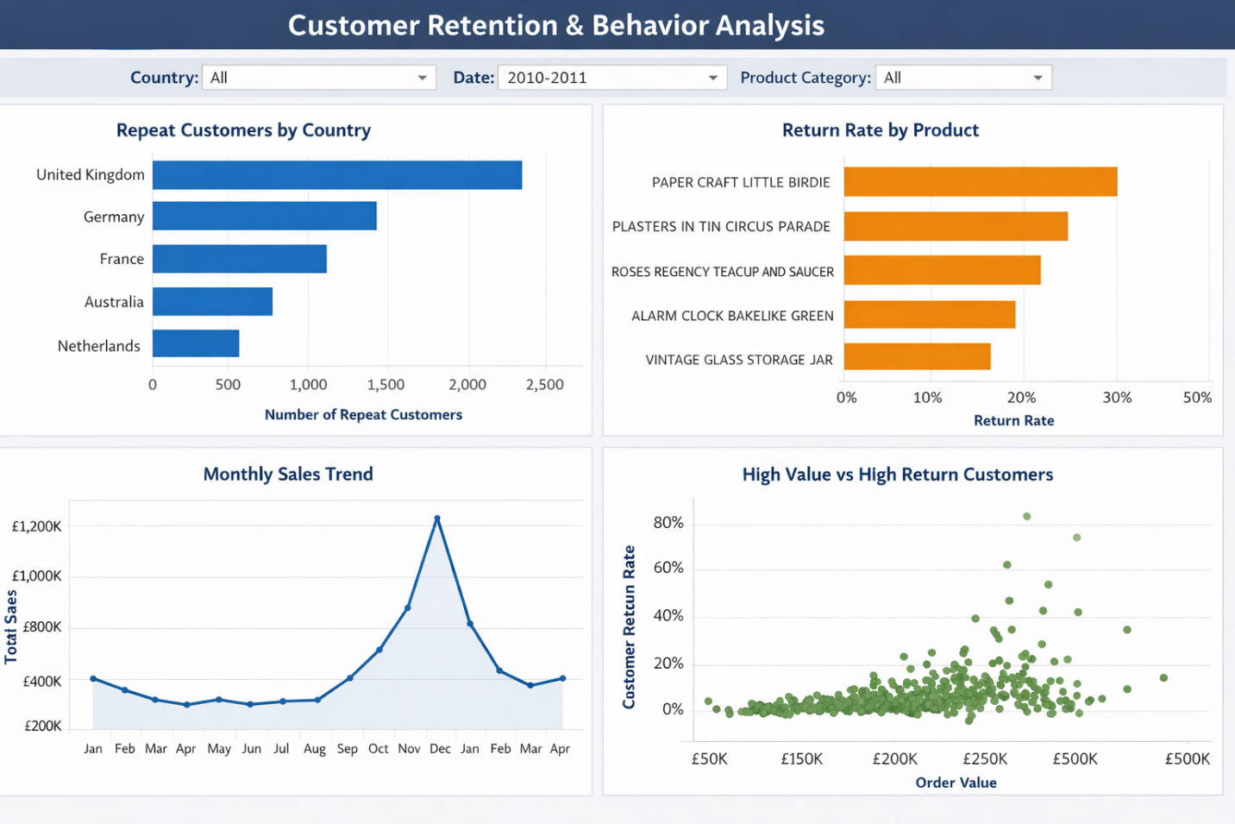
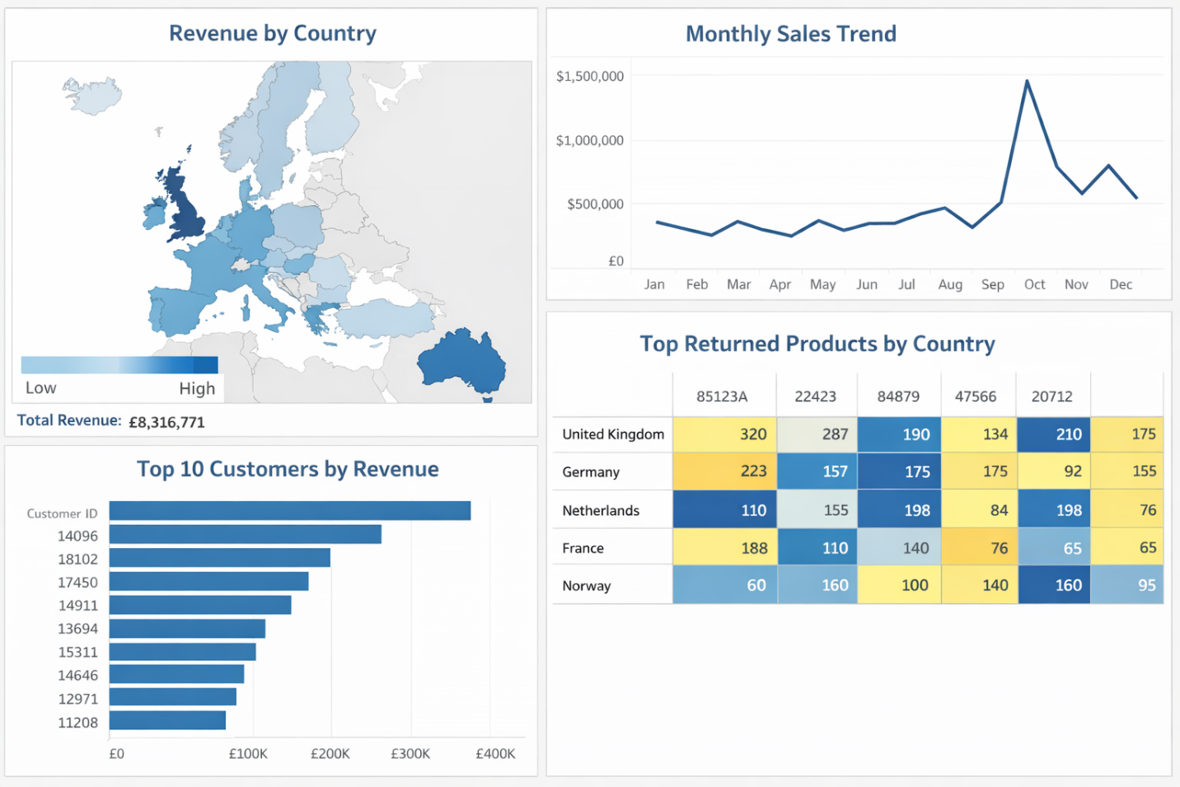

Business Insights
Customer & Country Insights
- The UK, Germany, and France have the highest number of repeat customers, indicating stronger customer loyalty in these markets.
- Countries with lower repeat customers show signs of potential churn and need engagement strategies.
- A small group of customers contribute a large share of total revenue (top 10 customers) → revenue is highly concentrated.

Returns & Product Insights
- Certain products show consistently high return rates across multiple countries, indicating possible issues with product quality, description, or customer expectations.
- Top 10 countries with highest returns are not always the top revenue countries → returns are a separate risk factor.
- Products with high returns but also high sales need review of product images, descriptions, and quality checks.

Seasonality (Time-based Trends)
- Sales peak during November–December (holiday season) due to gifting purchases.
- Lowest sales are seen in January–February, indicating a post-holiday slump.
- Marketing campaigns should be stronger before peak months to maximize revenue.

Risky Customers (High Value + High Returns)
- Some high-revenue customers also have high return rates, making them risky despite their value.
- These customers should be monitored separately and offered targeted support or incentives to reduce returns.

Geographic Performance
- Revenue is highly concentrated in a few European countries (especially the UK).
- Some countries show decent order volume but low revenue → possible pricing or product mismatch.

Final 3-Line Recommendation (For Leadership)
- Focus on loyalty programs in high-performing countries and engagement campaigns in low-retention regions.
- Improve quality control and product descriptions for high-return items to reduce refunds.
- Use seasonal marketing strategies (pre-holiday offers) and personalized incentives for high-value but high-return customers.

